**ITP Assignment 2**

Program to calculate age by finding difference between current date and date of birth.

IEC2021063 Javesh Lodha, IEC2021064 Yash Gupta, IEC2021065 Shashi Kumar Chaubey,

IEC2021066 Pavitra Pandey

Indian Institute of Information Technology, Allahabad

03-02-2022

***Abstract: In this paper we have devised an algorithm to calculate age by finding the difference between the current date and the date of birth.***

I. Introduction

Given the date of birth in - “DD MM YYYY” format, and the current date in the same format, we will calculate the age difference between the two.

We will use structures here to store the date of birth, current date and the difference between the two.

A structure is a user defined data type in C/C++. A structure creates a data type that can be used to group items of possibly different types into a single type.

II. Algorithm design

We have defined a structure named “date” here which contains three int data types named as days, months and years respectively.

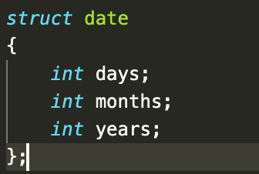

Then using this structure as,



1. Storing the dates in structures will decrease the written code as we don't need to write the same input/output statements for the date of birth, current date and the difference between the two again.

2. Now, after storing both the dates, we will take the difference between the current date and the date of birth. If the difference between the two dates is less than 0, we will carry over one month and add 30 to the difference, since every month does not have 30 days, we will add a correction factor over the months to equalize it.

We will add the correction factor by using the switch statement.

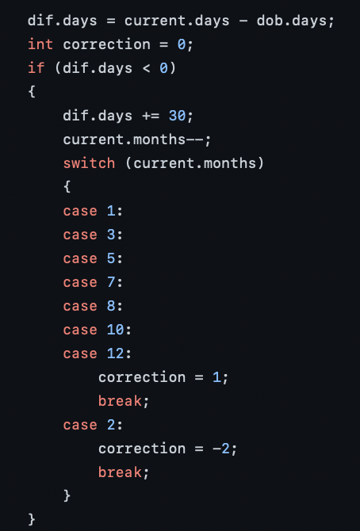

3. Now, we will continue to subtract the months of the two dates. If the difference is smaller than 0, we will borrow one from the year and add 12 to the difference of months.

4. Continuing this, we will calculate the difference between the years. If the difference between the two is negative, this means that the current date is before the date of birth, which is invaild, so we will output an invalid warning.

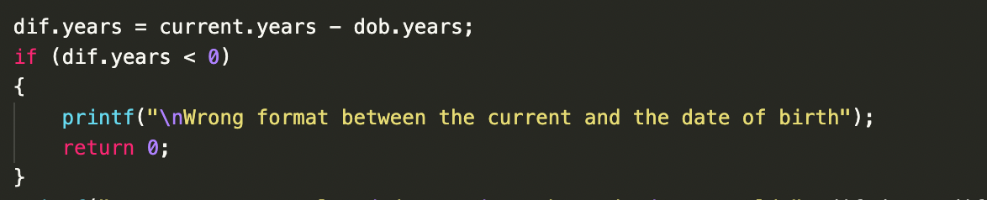

5. Now, we will display the difference between the two dates in the form of days, months and years.

III. Example

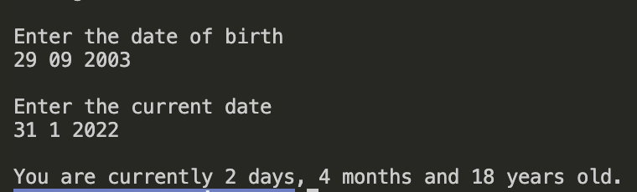

IV. Time Complexity

Since the process isn't dependent on any time factor, it will run in constant time, irrespective of the input values.

Hence, the program will be of O(1) complexity.

VI. Conclusion

So, we have used the properties of structures in this code to reduce the complexity of the code and make it more presentable while dealing with heterogeneous data types.

V. References

1. <https://www.geeksforgeeks.org/structures-c/>
2. <https://stackoverflow.com/>

GitHub repo link:

<https://github.com/pvtrpndy/ITP-2-2022.git>

ITP Project by:

IEC2021063 Javesh Lodha

IEC2021064 Yash Gupta

IEC2021065 Shashi Kumar Chaubey

IEC2021066 Pavitra Pandey

Raw Code:

